**PIZZA SALES SQL QUERIES**

**A. KPI’s**

**1. Total Revenue:**

SELECT SUM(total_price) AS Total_Revenue FROM pizza_sales;

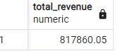

**2. Average Order Value**

SELECT (SUM(total_price) / COUNT(DISTINCT order_id)) AS Avg_order_Value FROM pizza_sales

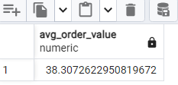

**3. Total Pizzas Sold**

SELECT SUM(quantity) AS Total_pizza_sold FROM pizza_sales

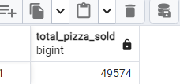

**4. Total Orders**

SELECT COUNT(DISTINCT order_id) AS Total_Orders FROM pizza_sales

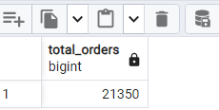

**5. Average Pizzas Per Order**

SELECT CAST(CAST(SUM(quantity) AS DECIMAL(10,2)) /

CAST(COUNT(DISTINCT order_id) AS DECIMAL(10,2)) AS DECIMAL(10,2))

AS Avg_Pizzas_per_order

FROM pizza_sales

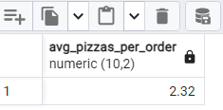

**B. Daily Trend for Total Orders**SELECT to_char(order_date, 'Day') AS order_day, COUNT(DISTINCT order_id) AS total_orders

FROM pizzas

GROUP BY to_char(order_date, 'Day');

***Output:***

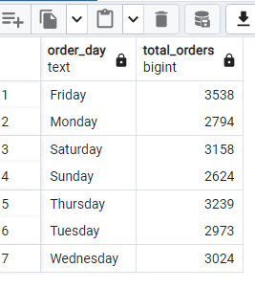

**C. Monthly Trend for Orders**

SELECT to_char(order_date, 'Month') AS Month_Name,

COUNT(DISTINCT order_id) AS Total_Orders

FROM pizzas GROUP BY to_char(order_date, 'Month')

ORDER BY Total_Orders DESC;

***Output***

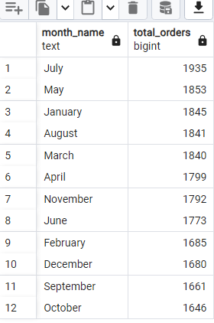

**D. % of Sales by Pizza Category**

SELECT pizza_category,

ROUND(SUM(total_price)::NUMERIC,2) AS total_revenue,

ROUND(SUM(total_price) * 100 / (SELECT SUM(total_price)

FROM pizzas)::NUMERIC, 2) AS PCTFROM pizzasGROUP BY pizza_category;

***Output***

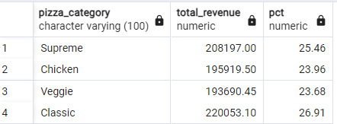

**E. % of Sales by Pizza Size**

SELECT pizza_size, CAST(SUM(total_price) AS DECIMAL(10,2)) AS total_revenue,

ROUND(SUM(total_price) * 100 / (SELECT SUM(total_price) FROM pizzas), 2) AS PCT

FROM pizzas

GROUP BY pizza_size;

***Output***

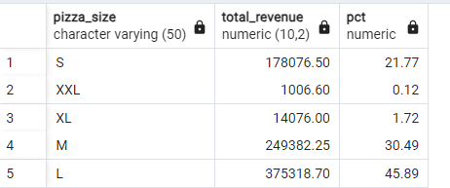

**F. Total Pizzas Sold by Pizza Category**

SELECT pizza_category, SUM(quantity) as Total_Quantity_Sold

FROM pizza_sales

WHERE MONTH(order_date) = 2

GROUP BY pizza_category

ORDER BY Total_Quantity_Sold DESC

***Output***

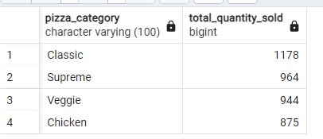

**G. Top 5 Pizzas by Revenue**

SELECT pizza_name, SUM(total_price) AS Total_Revenue

FROM pizza_sales

GROUP BY pizza_name

ORDER BY Total_Revenue DESC

LIMIT 5;

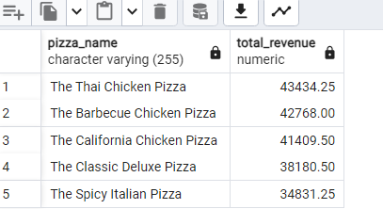

**H. Bottom 5 Pizzas by Revenue**

SELECT pizza_name,

SUM(total_price) AS Total_Revenue

FROM pizza_sales

GROUP BY pizza_name

ORDER BY Total_Revenue ASC;

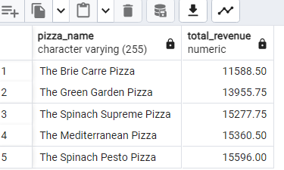

**I. Top 5 Pizzas by Quantity**

SELECT pizza_name, SUM(quantity) AS Total_Pizza_Sold

FROM pizza_sales

GROUP BY pizza_name

ORDER BY Total_Pizza_Sold DESC

LIMIT 5:

***Output***

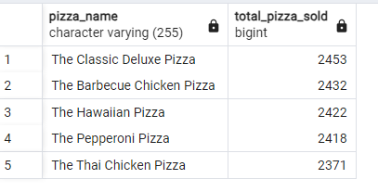

**J. Bottom 5 Pizzas by Quantity**

SELECT pizza_name, SUM(quantity) AS Total_Pizza_Sold

FROM pizza_sales

GROUP BY pizza_name

ORDER BY Total_Pizza_Sold ASC

LIMIT 5

***Output***

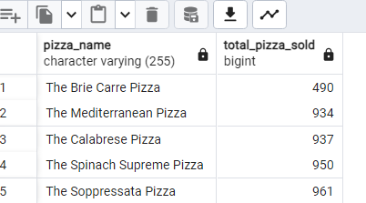

**K. Top 5 Pizzas by Total Orders**

SELECT pizza_name, COUNT(DISTINCT order_id) AS Total_Orders

FROM pizza_sales

GROUP BY pizza_name

ORDER BY Total_Orders DESC

LIMIT 5;

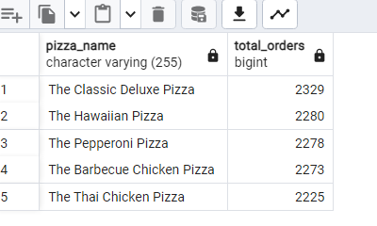

**L. Borrom 5 Pizzas by Total Orders**

SELECT pizza_name, COUNT(DISTINCT order_id) AS Total_Orders

FROM pizza_sales

GROUP BY pizza_name

ORDER BY Total_Orders ASC

LIMIT 5;

